Testing and Accessibility Report

Gareth Madoc-Jones ID:25646648

Edge Hill University

CIS 1705: Accessible Web Development and Design

Table of Contents

**Index Page** 2

Mobile Designs 3

Validation Testing 6

Manual Testing6

Functionality Testing7

Accessibility Testing8

Browser Accessibility 11

Accessibility Conformity14

HTML Validator14

**Product Page** 15

Mobile Design16

Validation Testing 19

Manual Testing19

Functionality Testing20

Accessibility Testing21

Browser Accessibility23

Accessibility Conformity30

HTML Validator30

**CSS Validation**31

style.css31

grid.css31

**References**31

**Index Page**

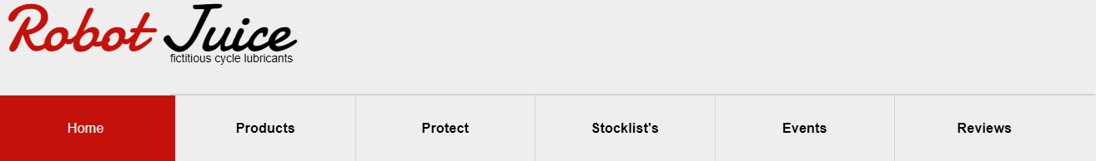

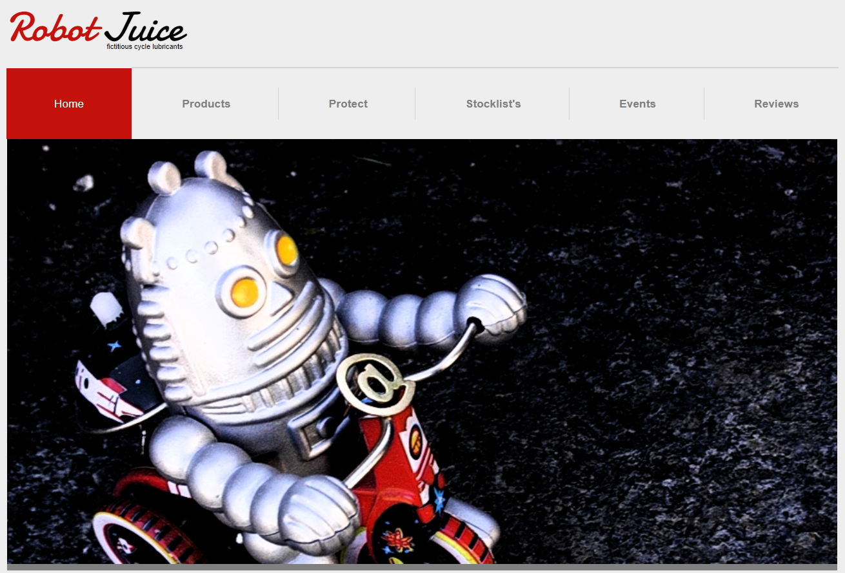

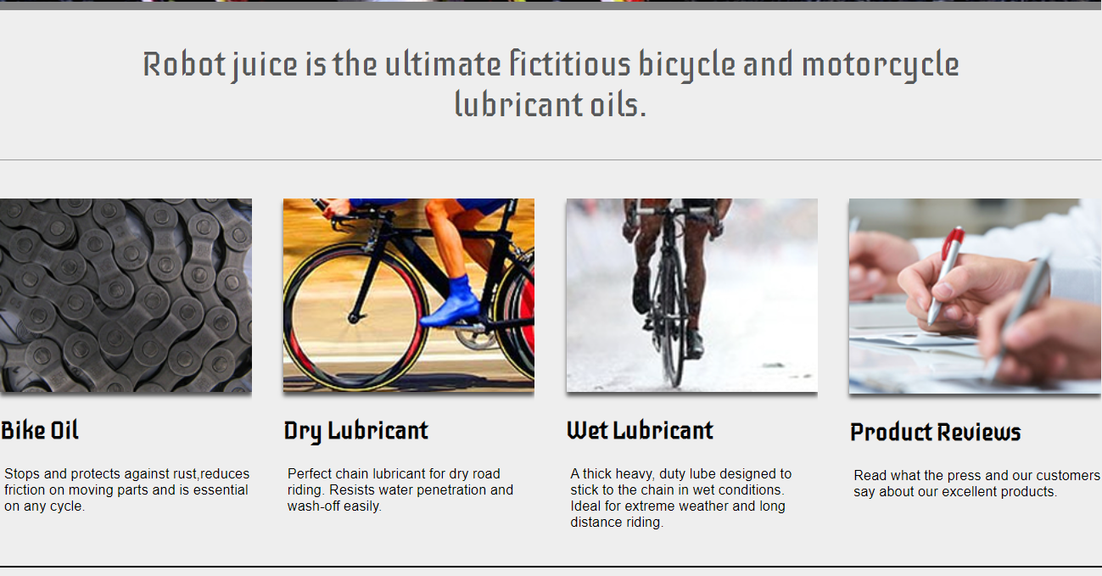

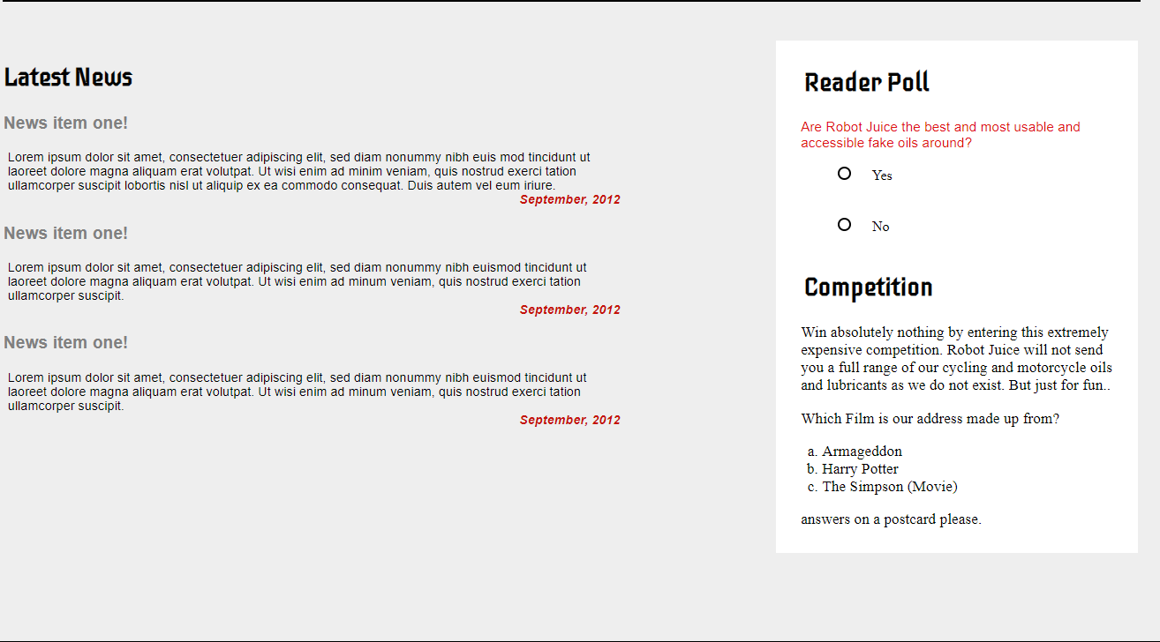

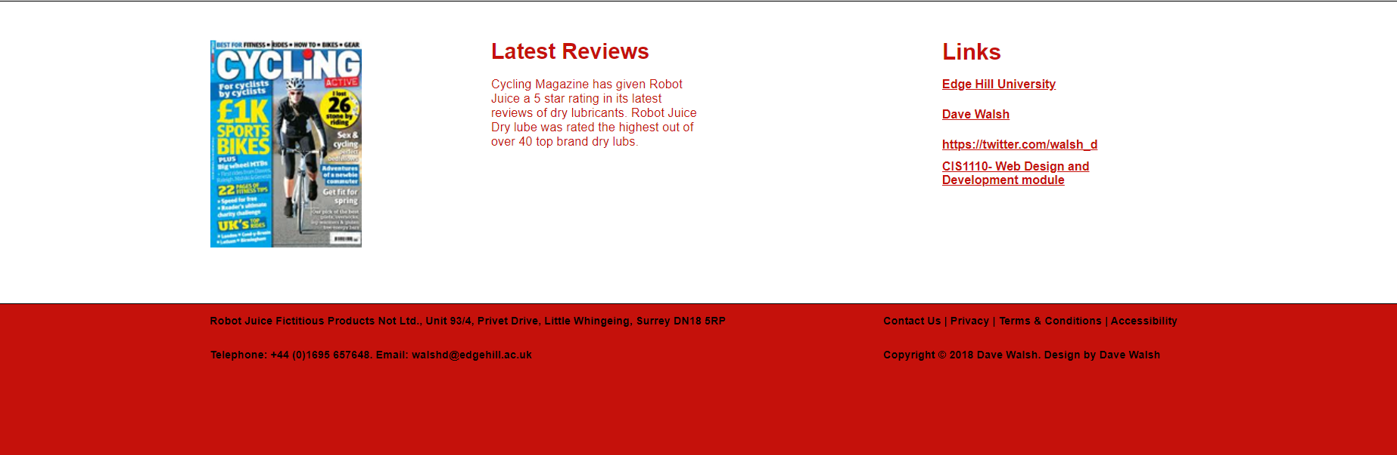

This is the Index page of the website before any testing has taken place. The final design of the webpage may look slightly different. It follows the structure of taking 80% of the size of the user’s screen so the webpage is fully symmetrical, and it sticks to the original design set for the webpage. The above screenshots show what the webpage will look like for a desktop user when the webpage is opened. All text and images have been sized so that they are readable and can be seen when the webpage is being used. All elements in the webpage have been given enough space so that no elements overlap each other which would hamper user experience with the website.

**Mobile Design**

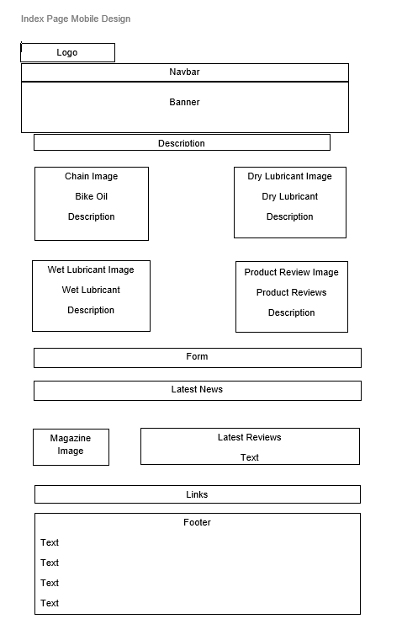

This is the original mobile design I made for my website. This design allows for all content to be easily viewable on a smaller screen. Before designing the mobile version of the webpage one key thing needs to be considered. The mobile design needs to be usable by touch screen as this is the main way of using a mobile. The button on the form needs to be big enough to be able to be clicked by somebody using touchscreen. Also, there are some concessions when designing for mobile that need to be made. A major one for this design is the abandoning of having most content be next to each other. In this design there is a small amount of content being next to each other, the content that is next to each other is mainly composed of photos that can be smaller so that they are not blurry or out of focus. The position of the logo, navbar, banner and description of Robot Juice are the exact same as the desktop design due to their only being one bit of content not two bits of content. The four images and the text have changed to be into two columns to allow the text and images to be visible. The form and latest news have been stacked on top of each other as two blocks. In the desktop design these two bits of content are together next to each other. The magazine image and latest reviews have been put together with the links below them instead of all three being placed in a row with each other. The footer has four rows of text instead of two columns and two rows. This mobile design allows for the content to be easily visible to mobile users since all content has enough space on the page so that it is not squashed in, and the website doesn't have a crammed in look.

**Outcome of Mobile Design**

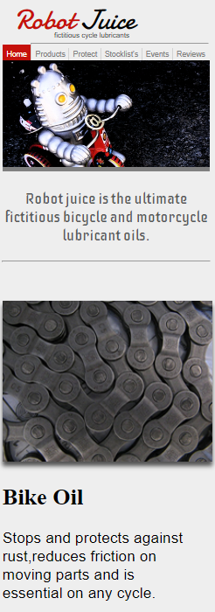

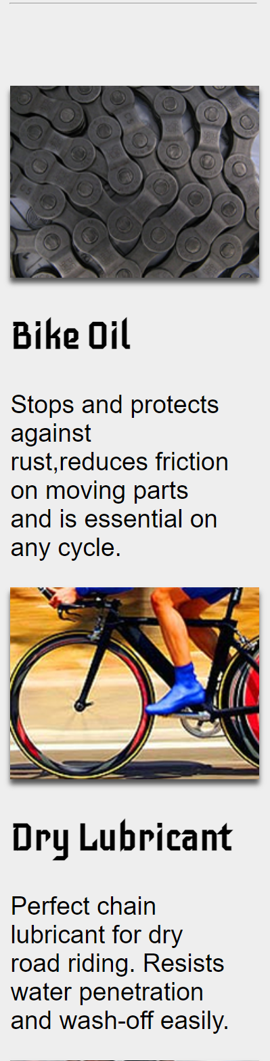

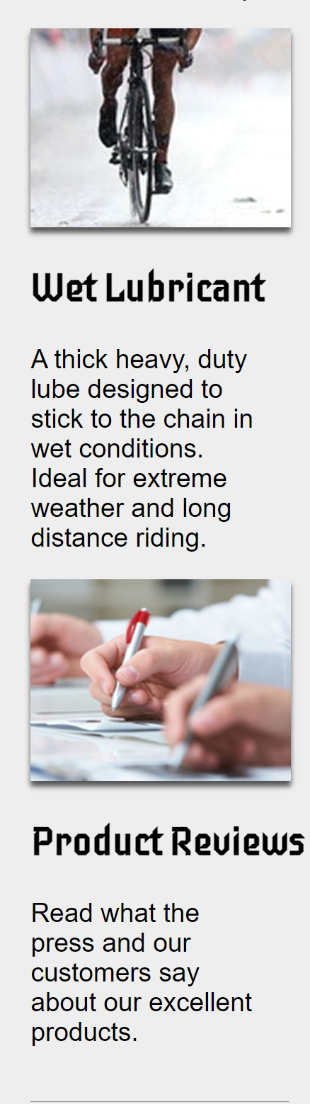

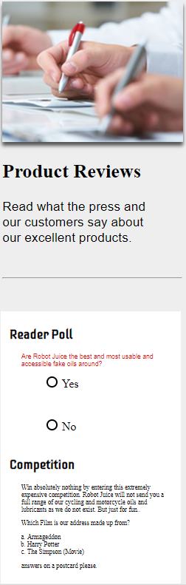

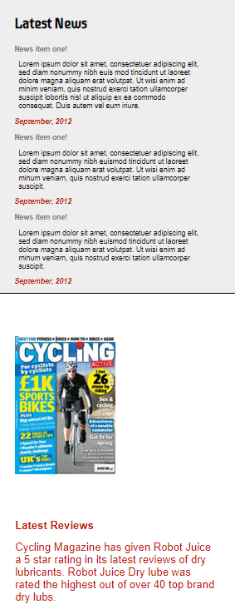

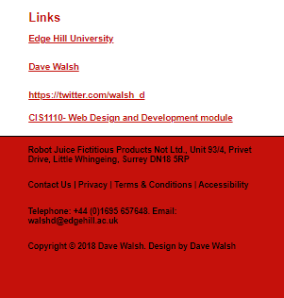

This is the outcome of the mobile design for the website. The design follows a one column structure where all the elements on the website are in a straight line allowing a mobile user to swipe down the website and see all the content. This design, however, does not stick to the original mobile design. Instead of content being put next to each other it is all either on top of or below other content. In practice having the content be next to each other on such a small screen was not a feasible option. Having all content be in one straight column improves the user’s experience of the webpage because all they must do is scroll down the webpage with a single finger to see all the content. Also, text would have had a squashed in and crammed look that would have severely damaged the user’s experience of the website. The text being crammed in would make it very hard to read since there would be no whitespace around the text. Having whitespace around the text and images splits the text from the background and makes the text stand out making it easier to read. All text in the mobile design is not in pixels instead it is in a measurement called VH. VH stands for viewpoint height. This means that the text will grow or shrink depending on the size of the screen that the website is being viewed on. This allows this design to be responsive to all types of mobile devices such as tablets or larger smartphones thus increasing the accessibility of the webpage by allowing a variety of webpages access to the website. The interactive features of the website, such as the form and links, have been given enough room to function when clicked on since a mobile device will be browsing this website using touch, therefore the links and buttons needed to be big enough to be touched with ease. The links should also open a new tab on the mobile device taking the user to the desired destination. They can then close the tab and use the webpage again when they are done. The text may look small when using a mobile emulation on a computer because the screen is far away from the user but when using a mobile phone, a user is more likely to be holding the phone closer to their face so the text will be easier to read. The images here for the webpage have been sized so they are not blurry when the mobile design is being used.

**Validation Testing**

Validation testing is the process of ensuring that the webpage meets the quality standards set by the customer and that the product meets the customer requirements. (Qubika 2022). To test the validation for this webpage, the requirements of the webpage need to be outlined and these need to be tested. For this project the requirements of this webpage are, the functionality of the webpage, the look of the webpage, the usability of the webpage and the accessibility of the webpage. For the functionality of the webpage this is if the interactive features and design of the webpage follow the desired outcome. This will be looked at with more depth further in this report under the functionality testing section of this report. The look of the website needs to follow the set design. For this webpage the design is strictly followed and the requirements for this design are followed. For the useability of the webpage this is if the webpage is fully usable for the users, and it has no errors or bugs when the user is using the webpage. This also includes if the website can be used by users with disabilities such as users who use a screen reader to access the webpage or users that can’t fully use a mouse and keyboard that rely on navigating the webpage by using the tab key on the keyboard. This will be further developed in the Manual Testing section of this report. For the accessibility of the webpage multiple points need to be considered. The code of the website needs to be accessible for anybody if they want to read the source code of the webpage so that they can understand how the webpage works. The content on the webpage needs to be accessible such as having correctly coloured text that is big enough for everyone to read. This will be explored more in depth later in this report.

**Manual Testing**

Manual Testing tests if the webpage can be used fully by users. This includes all users, such as users who have disabilities such as a visual impairment or mobility issues such as hand tremors that will hinder the user’s ability to successfully use the webpage. For users with visual impairments a screen reader will be necessary for them to use the webpage. For a screen reader to be used successfully the code needs to be fully functional and has no errors. This also includes that images have alt tags describing the image in words and that the text is spelt correctly and there are no spelling errors. When testing the webpage for this there were no errors in the code and no spelling errors, which would mean that a screen reader would read the webpage correctly. For users with mobility issues will rely on using the tab key to go through the webpage. The tab key should take the users to key parts on the webpage such as the product page link in the navigation bar, the radio buttons on the form and the links by the magazine image and latest reviews text. When testing this the tab key takes the user to the product section of the navigation bar. The user then must press the enter key to follow the link, then the tab key takes the user to the yes and no buttons on the form, and then the links for the webpage. This means that the webpage is fully accessible to users with mobility issues because the movement for the webpage can be easily done by pressing two keys. Also, the tab key takes the user to the key areas of content in the webpage such as the form and links.

**Functionality Testing**

|  |  |  |  |  |
| --- | --- | --- | --- | --- |
| # | Test | Expected | Actual | Outcome |
| 1 | Testing all Links on the website to see if they work. | Clicking on each link will take you to the expected page. | Edge Hill University link goes to the Edge Hill Website. The Dave Walsh Link allows the user to email Dave Walsh. The twitter link takes the user to the Dave Walsh twitter Page and The Module Link takes the User to the Module Information | No changes needed. |
| 2 | Image Loading | All images fully load onto the page. | All images load when the website opens. | No changes needed. |
| 3 | Testing if all elements are visible and don’t overlap. | No elements overlap each other. | No elements overlap with each other. | No changes needed. |
| 4 | The form is fully functionally. | The buttons on the form are fully functional and can be used. | The buttons on the form are clickable but cannot be unclicked. | Buttons need to be made unclickable. |
| 5 | Navbar links are fully functional. | Product link on the navbar should take user to Product Page. | Product link takes the user to the Product Page. | No changes needed. |
| 6 | All CSS font styles produce the correct outcome. | Text should be in the correct colour and font style. | All font styles and sizes match the desired outcome. | No changes needed. |
| 7 | All CSS grid styles produce the desired outcome. | Text and Images should be in the correct positions and Alignment. | Most text is in the correct position and alignment except the dates underneath the latest news text, needs to be closer to the main text. | Change the position of the dates to match the desired outcome.  Changes made. |

**Accessibility Testing**

**Lighthouse Testing**

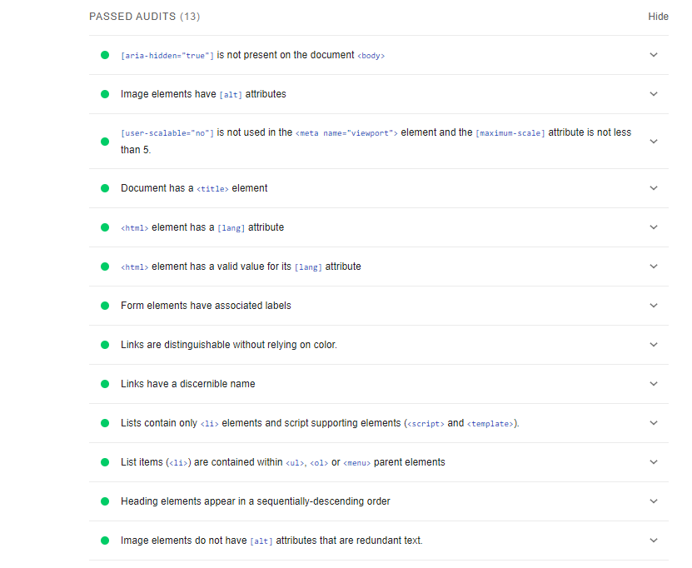

The first Accessibility Test performed for this website was the lighthouse test. This tests how accessible the webpage would be for browser users. As seen above this webpage has passed 13 tests, including having alt text for images that is not redundant and having suitable labels for form elements. This means that the website is accessible for disabled users because screen readers will be able to read out the text describing the image so visually impaired users can have a description of the image on the screen. These descriptions have been made so that they are relevant to the image in question and give an in-depth description of the image.

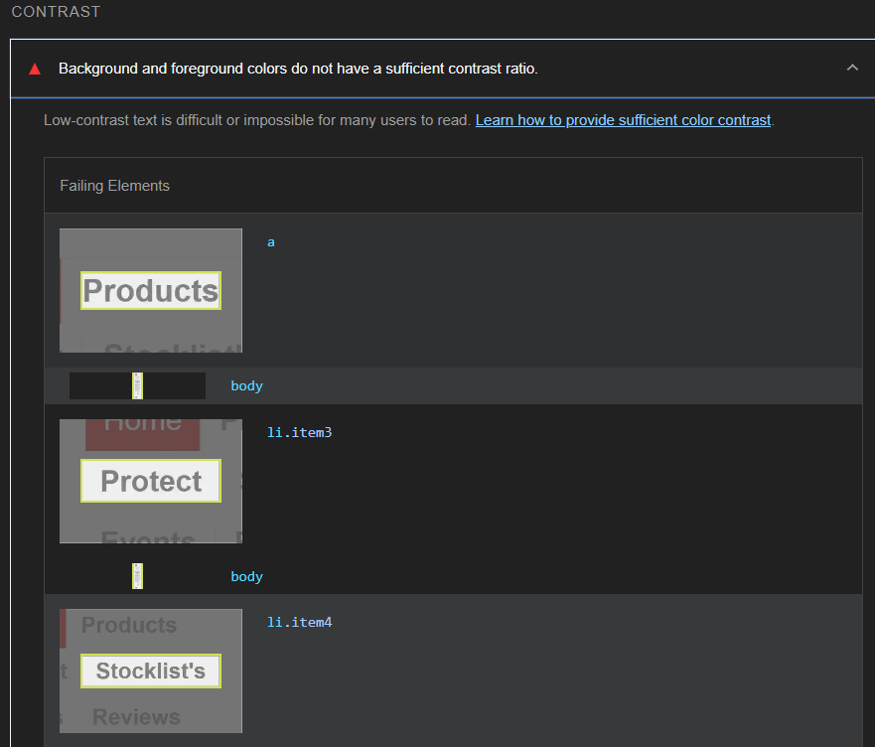

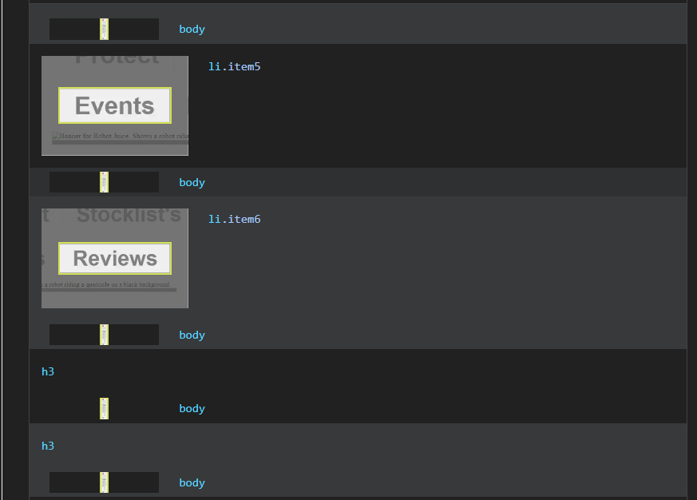

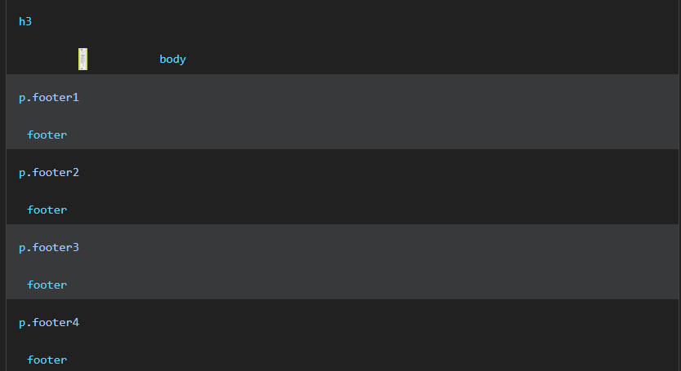

A lighthouse test also, provides any issues with the webpage. With this webpage there are significant contrast issues with the colouring of certain elements on the page. Contrast issues are extremely harmful to the accessibility of the webpage because they could potentially prevent colour blind users from using the webpage because they will not be able to read the content on the screen. All the above elements that fail the test need to be changed for it to pass so that the webpage is fully accessible and that colour blind users can access the content on the webpage with ease.

**ARC Toolkit**

The Arc Toolkit is another google development tool (Chrome Web Store, 2023) that tests the accessibility of a webpage. Unlike lighthouse the ARC Toolkit only shows the errors in the webpage so they can be addressed and fixed. The ARC Toolkit follows the WCAG guidelines (W3,2023) which are international guidelines set for the accessibility of webpages. These guidelines allow the webpage to be accessible to people with a variety of disabilities such as colour blindness, mobility issues and visual impairments. For this webpage the ARC toolkit produces 12 errors. All the errors are to do with contrast and colour.

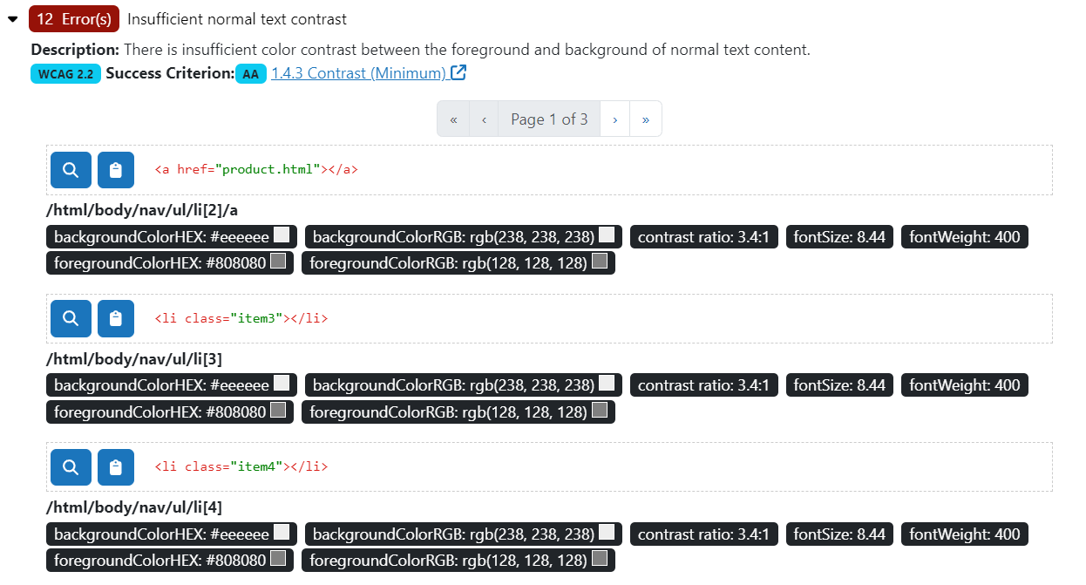

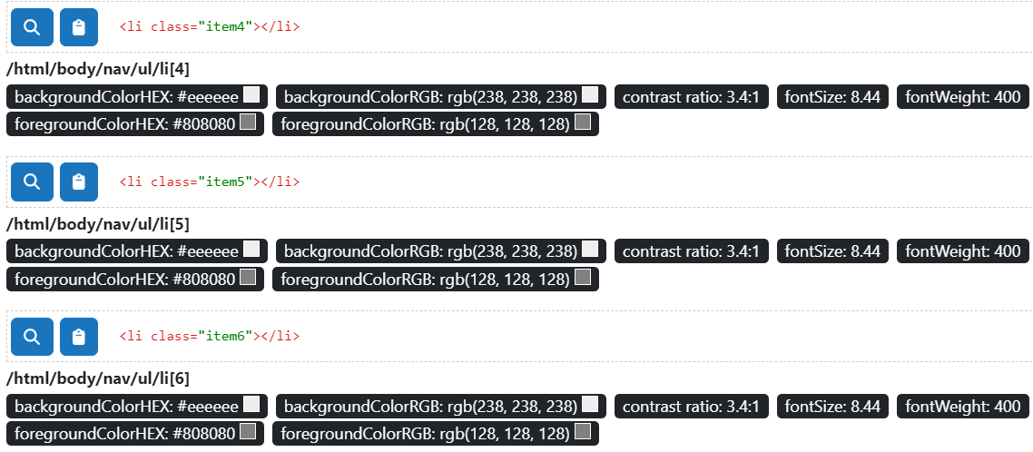

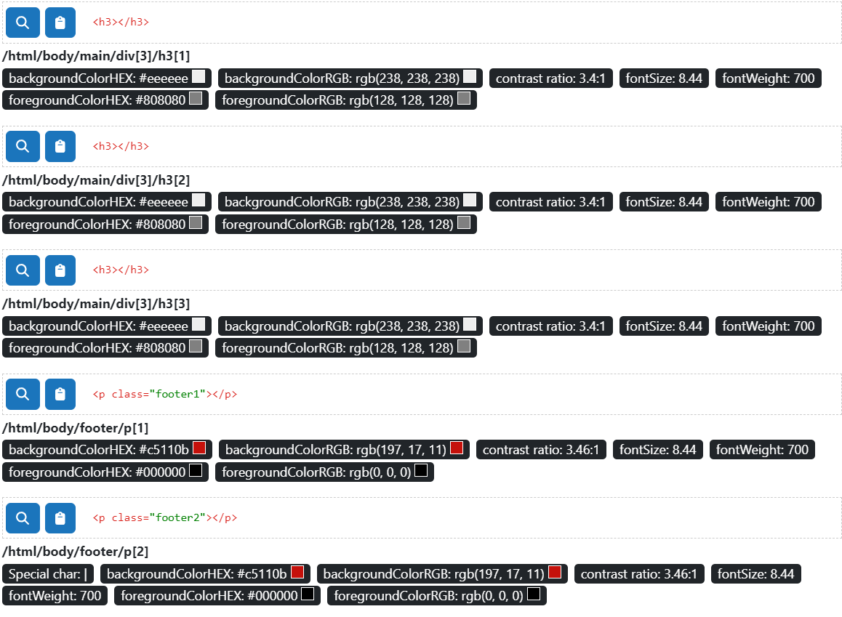

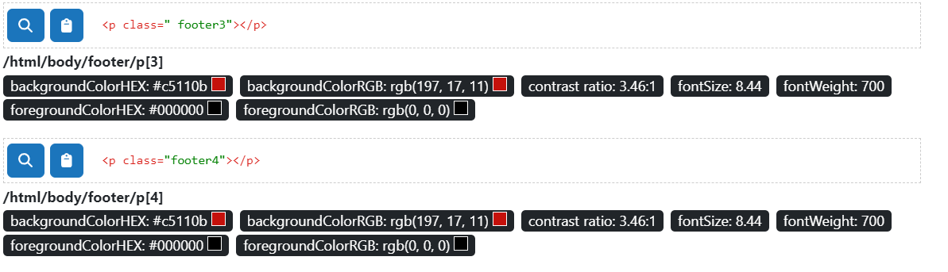

This webpage fails twelve times on contrast issues. As with lighthouse this means that colourblind people would have difficulty reading the text on the page. These errors will be addressed, and both tests will be performed again to ensure that there are no errors when testing this webpage.

After the necessary changes were made to the webpage the tests were performed again. These changes will influence the design of the webpage, but these changes are necessary to ensure that the webpage is fully accessible and usable by everyone.

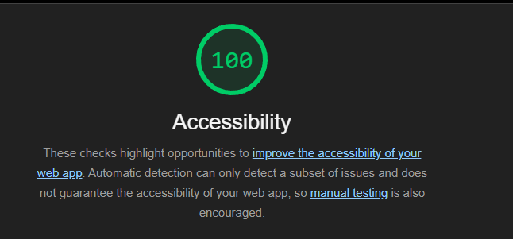



These changes were the elements in the navbar. The grey writing of the elements clashed in contrast with the grey of the background of the page, so they have been changed to be a solid black colour so that they are readable by everyone. This still applies to the news item one titles in the latest news section of the webpage. The grey writing again clashed with the grey background, so the writing had to be changed into a solid black. The final issue was the contrast between the footer and the text in the footer. The text remained the same, but the colour of the footer was slightly tweaked so that the text would be readable by everyone.

**Browser Accessibility**

To test the Browser Accessibility of this webpage three separate browsers were used to ensure that the browser had the same desired output for all browsers. Testing Browser Accessibility is an extremely useful test in web development. It ensures that the webpage is accessible to a huge range of people. If a web developer assumed that everyone used the same browser, then their webpage would be severely limited in who could access the content on the page. Testing multiple browsers also gives a more in depth look into any errors the webpage may produces and these can be fixed so that the website runs correctly for everyone. For this test Google Chrome, Microsoft Edge and Opera These three browsers are used by most users so testing them will see if a variety of users can access the webpage. To test these four key elements on the website are tested to ensure that the no matter the browser the website looks the same. The navbar, the four separate images with text, the latest news and form section and the footer. These four elements provide a good overview as to if the website runs correctly on the separate browsers.

**The results for Google Chrome**



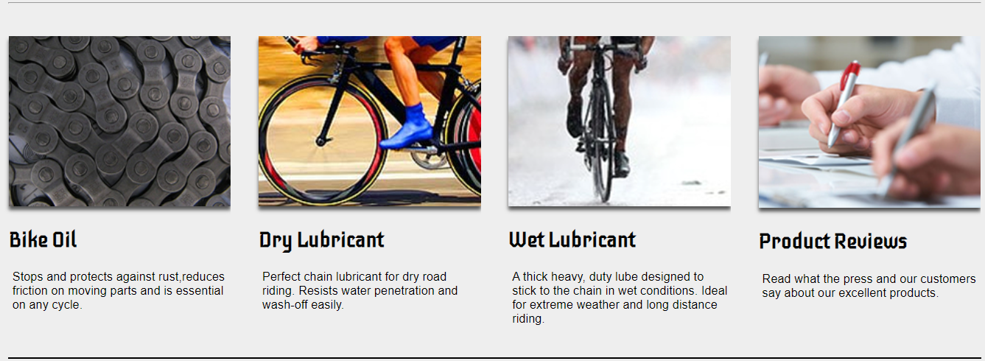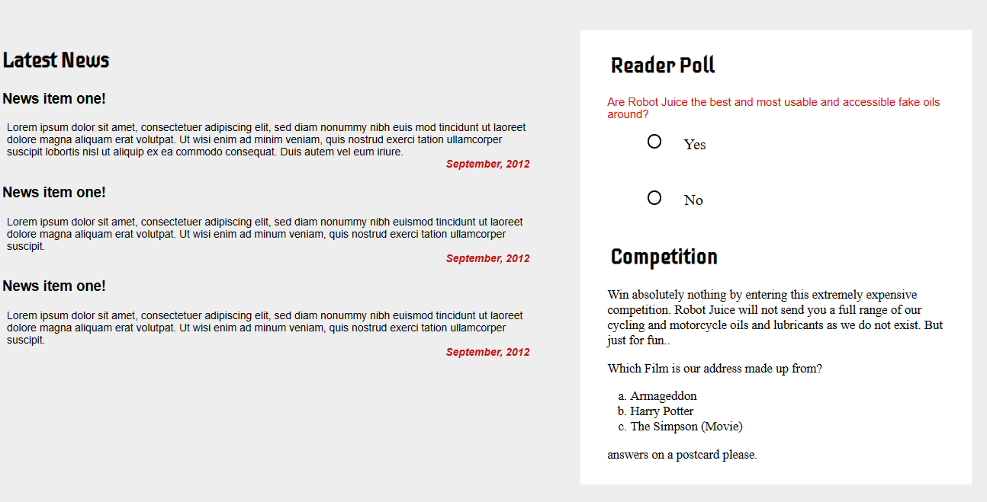

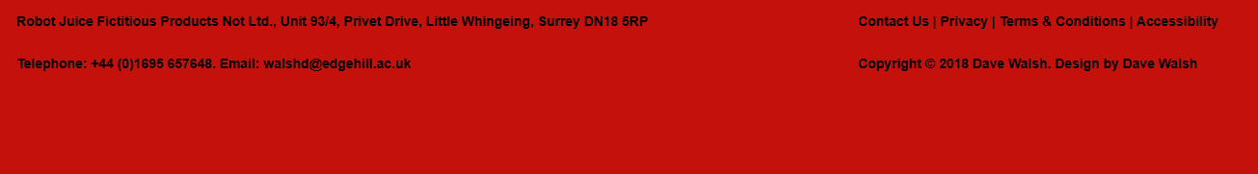

**The results for Microsoft Edge**



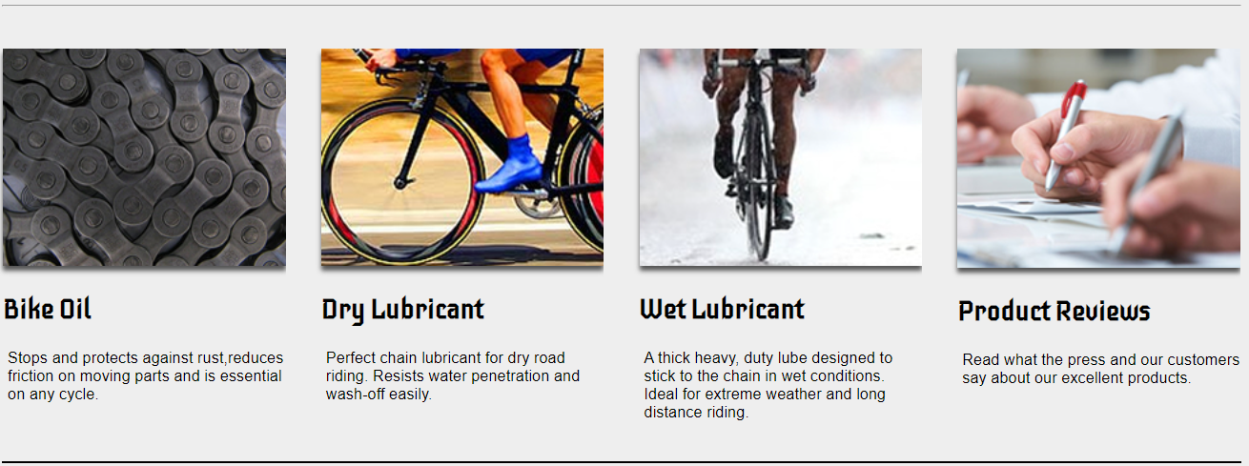





**The results for Opera**



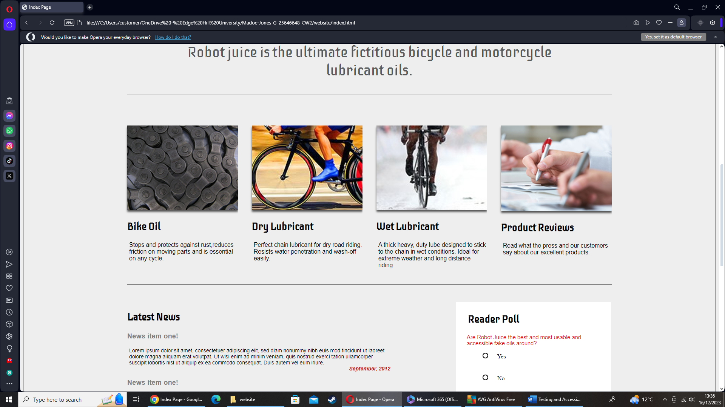





All three different browsers produce the exact same output for the website. Each browser has a unique way of running the website so with all browsers running the webpage correctly means that there are no bugs that limit the usability and functionality of the webpage. They are all the exact same meaning that users who use different browsers will be able to use the website. These four major elements in the webpage are varied enough to test if the browser accessibility of the webpage because they are major parts of the page. If these elements didn’t function correctly then the whole website itself would be heavily damaged. The three browsers tested here offer a variety of ways the website can be used. Microsoft Edge and Google Chrome are heavily popular with lots of people using both the browsers and opera can be used by desktops and mobile devices. Using a browser that supports both mobile and desktops allows testing of how a mobile device will handle the webpage. Testing the mobile version of the webpage in opera provided no issues with the functionality of the mobile webpage.

**Accessibility Conformity**

When developing this webpage certain accessibility requirements need to be followed to ensure that the website is accessible for all. The code in this website has a clear logical structure. The code is structured in the same way as the webpage itself. The elements are in the order that they appear in the webpage. The logo being the first element and the footer being the last element. This allows the code to be easily read by anyone and it can be understood even by users who do not have a background in web development. All images in this webpage have suitable alt tags describing the image so screen readers can read the alt text instead of producing nothing. The alt tags are needed so that users with visual impairments can have suitable access to the webpage and will be able to understand what the images are meant to be and what they are meant to look like. There are also, users with mobility issues that need to be considered. For a user with mobility issues the website needs to be keyboard accessible. This means that the webpage can be navigated by using the tab key. This has been tested in the Manual testing section of the report but to summarize the webpage is keyboard accessible because the key elements of the webpage the navbar the form and the links are the first elements to be accessed by using the tab key. As tested in the in the Accessibility Testing section in this report all elements in the webpage meet the contrast and colour guidelines. These guidelines ensure that the webpage can be used by users with colour blindness. If the webpage was not accessible to this demographic, then they would have grounds to take legal action against Robot Juice because a webpage should be designed for use by everyone.

**HTML Validator**

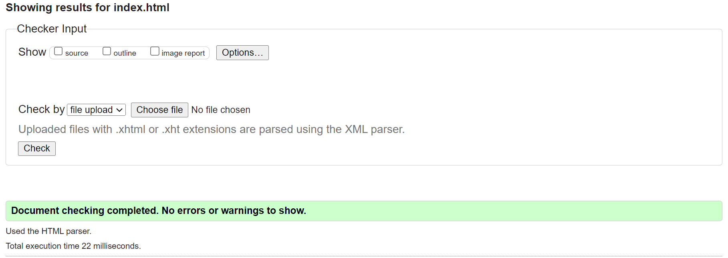

This is a HTML Validation for the index page of the website. As shown in the image above there are no errors showing for any of the code in the webpage has errors. This means that the website code will be fully functional and there is no broken code in the webpage meaning that the users won’t have any issues with elements in the webpage loading in. If the HTML code has a single error, it would severely hamper user experience. It would limit a screen readers capability of reading the webpage therefore reducing the accessibility of the webpage because users with visual impairments rely on a screen reader as there way of accessing the content on the website, without it they would have no way of interacting with the website successfully and it would limit the amount of users accessing the webpage therefore costing Robot Juice money as well as the potential to be facing lawsuits from affected users.

**Product Page**



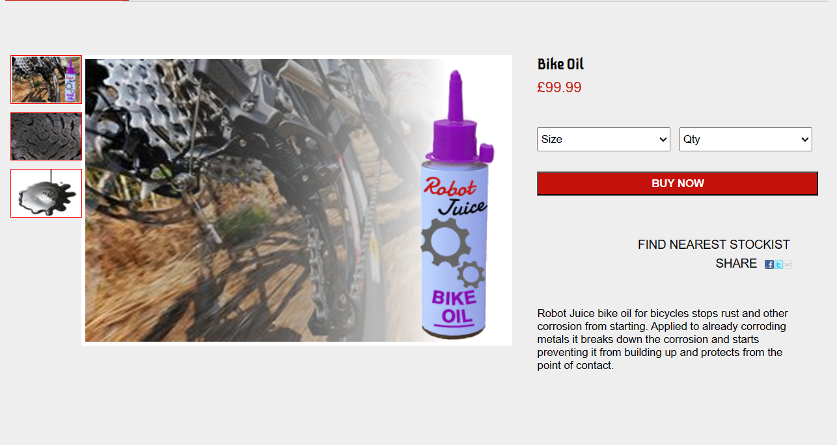

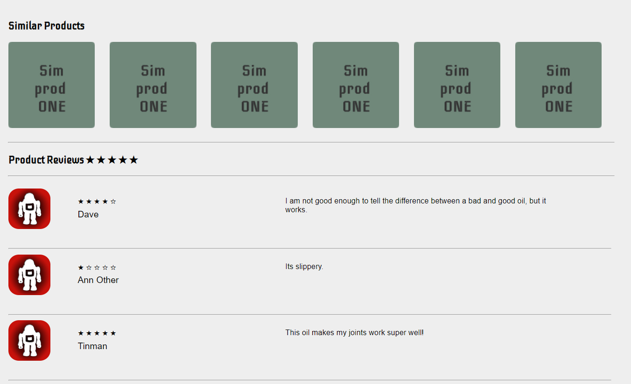

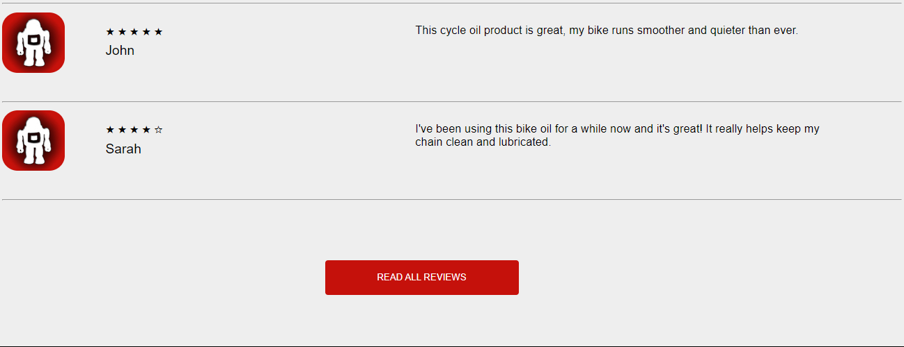



This is the Product page of the website before any testing has taken place. The final design of the webpage may look slightly different. It follows the structure of taking 80% of the size of the user’s screen so the webpage is fully symmetrical, and it sticks to the original design set for the webpage. The above screenshots show what the webpage will look like for a desktop user when the webpage is opened. All text and images have been sized so that they are readable and can be seen when the webpage is being used. All elements in the webpage have been given enough space so that no elements overlap each other which would hamper user experience with the website.

**Mobile Design**

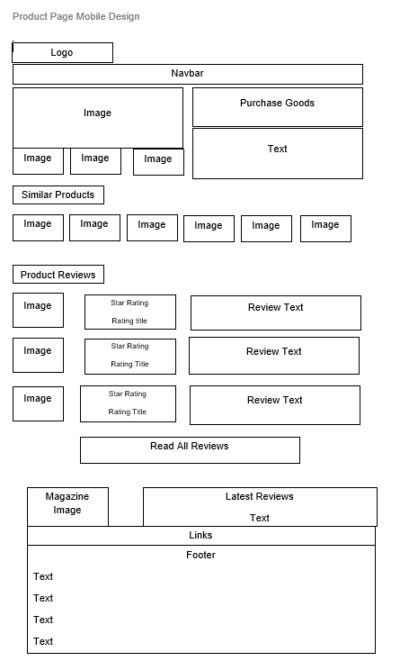

This is the original mobile design for the product page. This design stays true to the original desktop design by having most content that is put together still be put together instead of inline. The content that is together is mainly images and small paragraphs of text that can be put together without issue. The logo and navbar placement stick to the desktop design. The purchasing of goods has changed compared to the desktop design. Instead of the images being to the left of the main image they are below the image to allow space for the images, so they are not crammed in. The main structure has stayed the same with just spacing between the elements being reduced and the size of the elements being reduced. The similar products section layout stays true to the desktop design with the images being heavily shrunk to allow this to happen. The images should be still visible. The product reviews have the same layout as the desktop design. However, when applied the different reviews will take a lot more height than on the main desktop website. This is to ensure that the text is readable and is not crammed in. The image will be small to ensure that the text has enough space to be visible. The latest reviews section and the footer are the exact same as the index page.

**Outcome of Mobile Design**

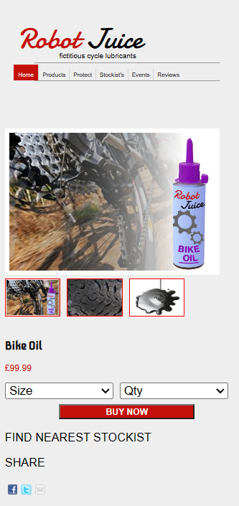

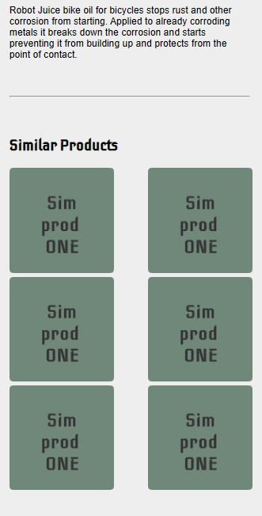

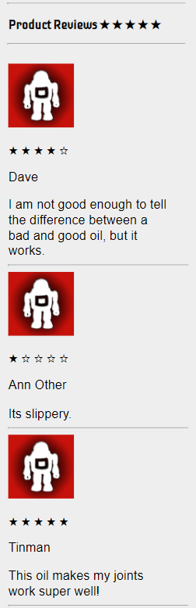

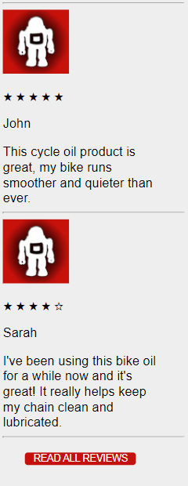

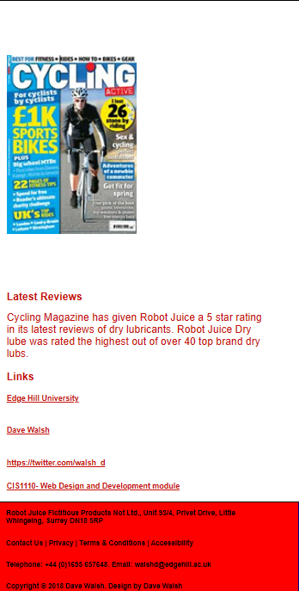

This is the outcome of the mobile design for the product page. This uses the same principles as the index page. It is a one column structure with content being in one straight line. The final design strays from the initial mobile design. The drop-down sections of the product page in the buy section have been made big enough to work using fingerprint. This is important as this is a source of revenue for Robot Juice. As well as the drop-down menus the BUY NOW, button has been made big enough to work using a fingerprint. All images have been sized so that they are visible on a mobile device. The sim product images are not in one straight line instead they are in two small columns to ensure that they are visible images and are not blurry in any way. The purchase goods section has no content to the right of the main images instead the writing and share links are below the main images. This is done because in practice the writing would have been too small if it was placed to the right of the webpage. The product reviews have been changed significantly to the original design. The product reviews have all the content in one column with the writing below the image instead of to the right of the image. The READ ALL REVIEWS button has also been made big enough to work on a mobile device so that mobile users can read all the product reviews on their phone. When the button is clicked all the reviews should follow the one column structure set by the previous reviews. This design had to be changed since if the original design was followed then the review text would be too small to be readable by all users. Older users or users with visual impairments would be unable to read the text making the webpage inaccessible. The latest reviews and footer follow the same outcome as the mobile design for the index page. The font size is in the same unit of measurement as the index page VH. VH is viewpoint height, and it is an accessible way of sizing text because text will increase and decrease in size depending on the size of the device the website is being used on. All images in the webpage are set using a % this means that as the size of the screen increases, the size of the image increases at the same rate keeping the structure clear throughout.

**Validation Testing**

Validation testing is the process of ensuring that the webpage meets the quality standards set by the customer and that the product meets the customer requirements. (Qubika 2022). To test the validation for this webpage, the requirements of the webpage need to be outlined and these need to be tested. For this project the requirements of this webpage are, the functionality of the webpage, the look of the webpage, the usability of the webpage and the accessibility of the webpage. For the functionality of this webpage several aspects of the webpage need to be thoroughly tested to ensure maximum efficiency and functionality. This webpage is the product page which will be the main source of income from the website because it has a section focused on selling products. This will be focused on in the functionality testing section of the report where several features will be tested thoroughly to make sure they work. The look of the webpage has the same focus as the index page, that all content has the desired output and matches the set design for the website. For the accessibility of the webpage, the content buying section needs to be accessible for all users to maximise the outcome from the website. If the buy now section is not accessible, then the company will lose lots of money from missed purchases by users with disabilities. The READ ALL REVIEWS button also needs to be accessible so that it can be used by all users. The content loaded when this button is clicked needs to be accessible so that it can be read by screen readers. This will be explained in a more in-depth way during the accessibility testing of this report.

**Manual Testing**

Manual Testing tests if the webpage can be used fully by users. This includes all users, such as users who have disabilities such as a visual impairment or mobility issues such as hand tremors that will hinder the user’s ability to successfully use the webpage. For users with visual impairments a screen reader will be necessary for them to use the webpage. For a screen reader to be used successfully the code needs to be fully functional and has no errors. This also includes that images have alt tags describing the image in words and that the text is spelt correctly and there are no spelling errors. When testing the webpage for this there were no errors in the code and no spelling errors, which would mean that a screen reader would read the webpage correctly. For users with mobility issues will rely on using the tab key to go through the webpage. When testing the tab key movement for this webpage the tab key takes the user to the dropdown menus to select the product they want and the amount they want then they will be taken to the BUY NOW button to buy their product. All the users would have to do is click the enter button to confirm their purchase or use the arrow keys to select the dropdown values they want. The next tab key then takes the user to the READ ALL REVIEWS button which when the enter key is clicked will load all the reviews for the website. The tab key will then take the user to the link section of the webpage. It will then start at the first link and then progress down until the last link. This is the same as the Index Page. The tab key therefore takes the user to the important sections of the webpage the purchasing of goods the button needed for the reviews and the links on the webpage.

**Functionality Testing**

|  |  |  |  |  |
| --- | --- | --- | --- | --- |
| # | Test | Expected | Actual | Outcome |
| 1 | Testing all Links on the website to see if they work. | Clicking on each link will take you to the expected page. | Edge Hill University link goes to the Edge Hill Website. The Dave Walsh Link allows the user to email Dave Walsh. The twitter link takes the user to the Dave Walsh twitter Page and The Module Link takes the User to the Module Information. | No changes needed. |
| 2 | Image Loading | All images fully load onto the page. | All images load when the website opens. | No changes needed. |
| 3 | Testing if all elements are visible and don’t overlap. | No elements overlap each other. | No elements overlap with each other. | No changes needed. |
| 4 | The buy now section is fully functional. | The drop-down lists are fully functional, and the button is clickable. | The drop-down lists are fully functional, and the button is clickable. | No changes needed. |
| 5 | Java Script | Java Script should load reviews when read all reviews button clicked. | JavaScript loads reviews from the API but SHOW ALL REVIEWS button does not function. | Script works as intended however, show all button can work infinitely.  Changes made |
| 6 | All CSS font styles produce the correct outcome. | Text should be in the correct colour and font style. | All font styles and sizes match the desired outcome. | No changes needed. |
| 7 | All CSS grid styles produce the desired outcome. | Text and Images should be in the correct positions and Alignment. | All text and images are in the correct position with the desired outcome. | No changes needed. |

**Accessibility Testing**

**Lighthouse Test**

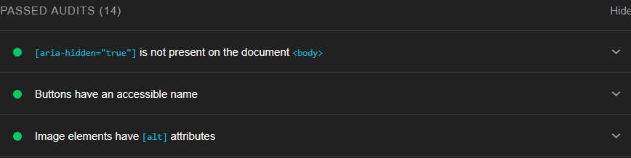

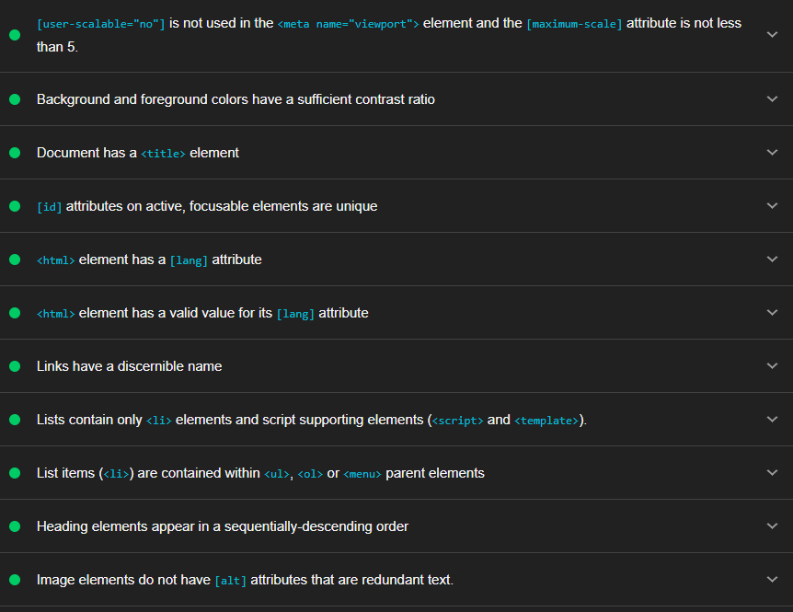

The first Accessibility Test performed for this website was the lighthouse test. This tests how accessible the webpage would be for browser users. As seen above this webpage passes 14 tests. The images have suitable alt text allowing visually impaired users to understand what the images contain. Background and foreground have a suitable contrast ratio, due to the same changes made for the index page contrast being carried over to the product page, making it easier for users with colour blindness to read the content on the webpage.

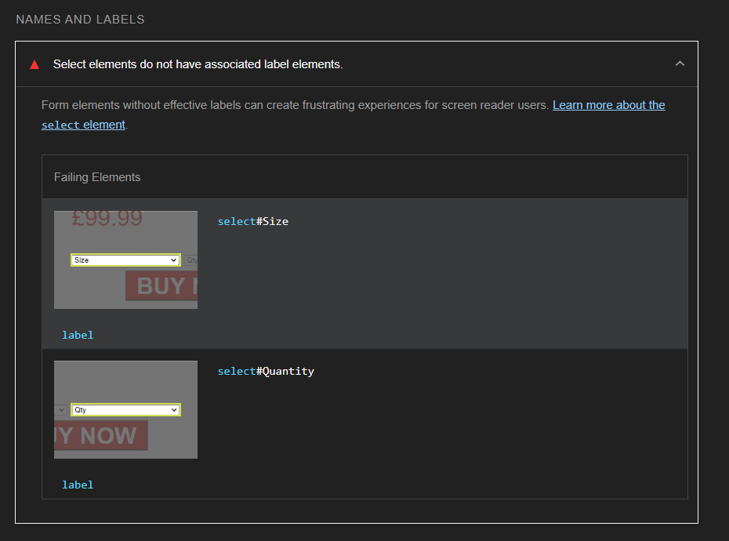

Above are the failed elements of the product page. The two buttons don’t have a suitable label. This means that when a screen reader is reading the webpage the dropdown lists will be skipped by a screen reader. This limits the potential income from this section of the webpage because a huge section of users will not be able to purchasing goods as well as making the webpage inaccessible which could cause legal issues.

**Arc Toolkit**

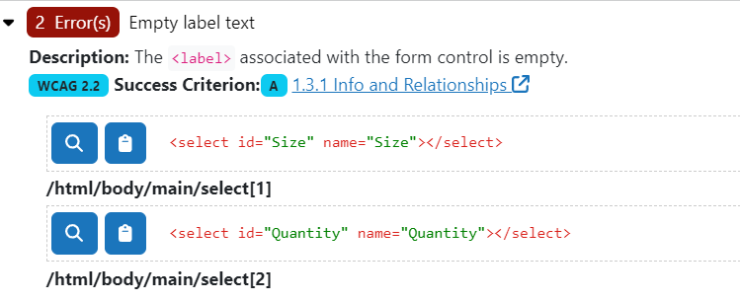

These are the two same errors as in the lighthouse test. Unlike the lighthouse test the Arc Toolkit provides the associated WCAG guidelines (W3,2023) for the correct way for the content to be performed so that there are no errors. The associated guidelines have been attached to the errors providing the legislation associated with that guideline that was breached.

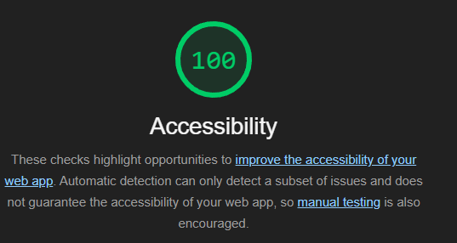

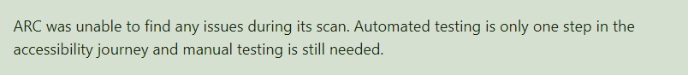

The changes made are the labels for the select elements. The labels before had no text to them which caused the error. This error would have caused any screen reader to skip over the drop-down menu in the webpage which would have limited the functionality of the webpage. Fixing the error meant adding the text to the label to make the labels function. Then the text got added to the page so to fix this the labels were made the same colour as the background of the webpage and the font size was set to 0px, so no space was taken by the labels. The labels despite being hidden on the screen will still be accessible to the screen readers therefore allowing users who rely on screen readers to have access to the webpage and all the content on the webpage. If these labels were not hidden, then they would cause huge issues to the structure of the webpage by moving the drop-down lists causing other things to move. The font being hidden does not prevent the label from functioning for a screen reader. The label is the first thing the screen reader will read for the drop-down menu therefore it is important that it is thoroughly labelled.

**Browser Accessibility**

To test the Browser Accessibility of this webpage three separate browsers were used to ensure that the browser had the same desired output for all browsers. Testing Browser Accessibility is an extremely useful test in web development. It ensures that the webpage is accessible to a huge range of people. For the product page browser testing is essential because the product page is where most of the income for the website comes from. The browsers used in this test will be Google Chrome, Microsoft Edge and Opera. These browsers will be used to test 4 key elements for this webpage. The four key elements tested in this webpage will be the buying section the similar products section, the product reviews and the application of the READ ALL REVIEWS button. The product reviews will be tested before the button is clicked and after the button is clicked to ensure that the structure of the webpage will be universal for all browsers. The buying section needs to be universal to ensure that it works for everyone so no income will be lost. Also, if the buying section has any small errors that limit its functionality it could cause a lawsuit, such as if the size or qty drop down menus output the wrong thing, and someone does not receive what they ordered then they could sue on the grounds of false advertising.

**Results for Google Chrome**

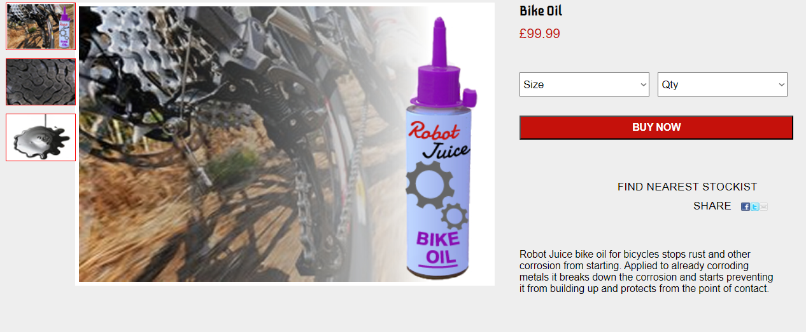

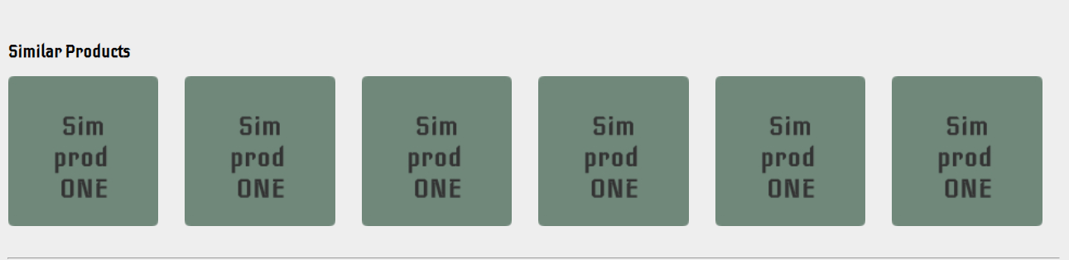



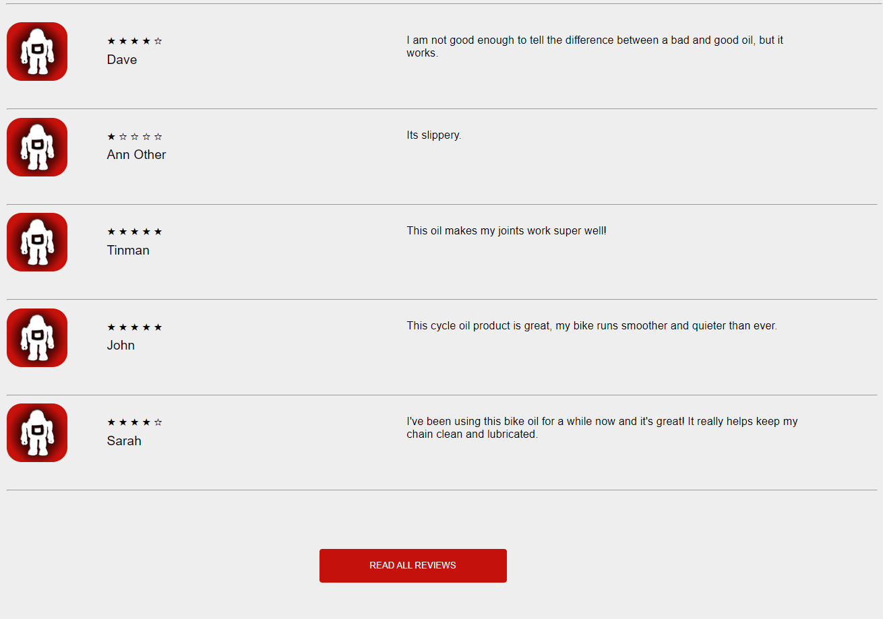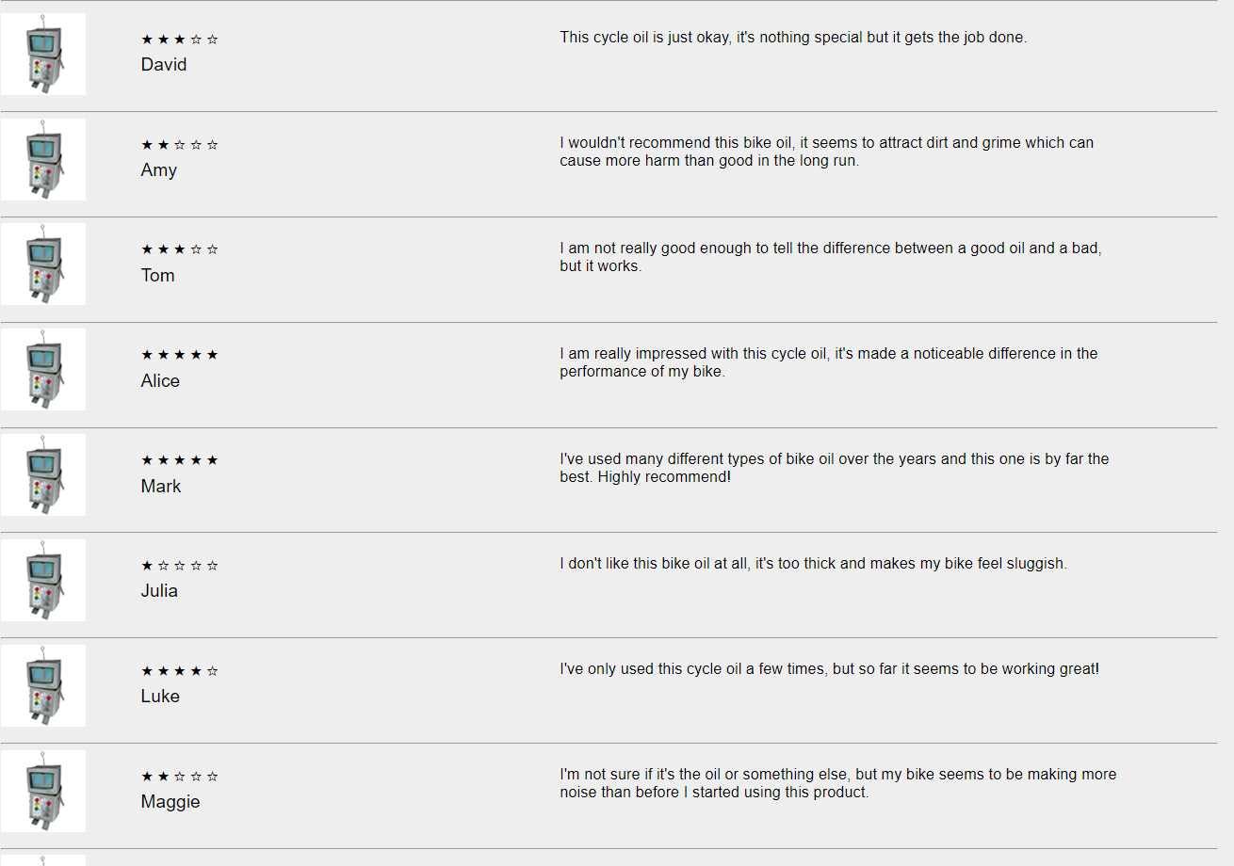

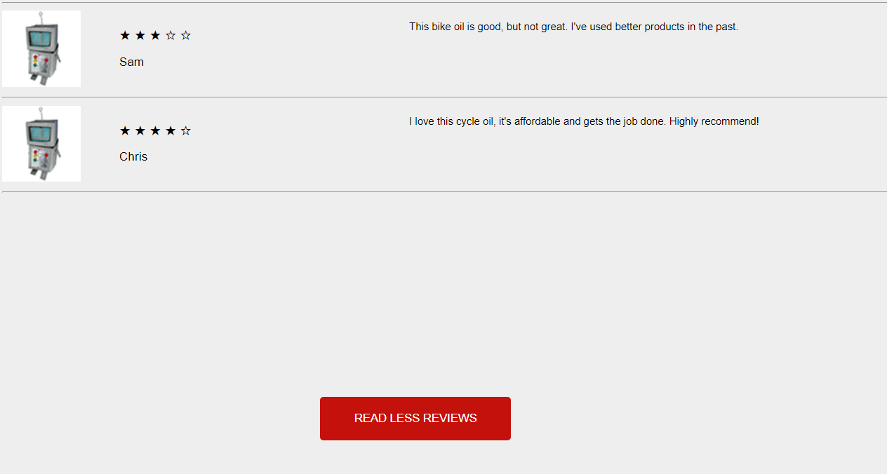

**Results for Microsoft Edge**







**

**Results for Opera**









As seen above on all browsers the webpage looks identical. This shows that the source code for the webpage is accessible to all browsers so that the webpage can be used by every browser. Opera as mentioned in the Index Page Browser Accessibility section is a mobile and desktop browser so knowing that the webpage looks identical on that site when compared to other browsers means that the webpage should theoretically be usable on mobile devices due to webpages on opera being able to be used on a mobile device.

**Accessibility Conformity**

When developing this webpage certain accessibility requirements need to be followed to ensure that the website is accessible for all. The code in this website has a clear logical structure. The code is structured in the same way as the webpage itself. The elements are in the order that they appear in the webpage. The logo being the first element and the footer being the last element. This allows the code to be easily read by anyone and it can be understood even by users who do not have a background in web development. All images in this webpage have suitable alt tags describing the image so screen readers can read the alt text instead of producing nothing. The alt tags are needed so that users with visual impairments can have suitable access to the webpage and will be able to understand what the images are meant to be and what they are meant to look like. The buy now section has been given suitable id tags describing what they are so that users with visual impairments that rely on screen readers can use the drop-down menus. The website needs a suitable tab movement structure. The tab movement for this webpage has been thoroughly tested in the manual testing section of this report but for this webpage the tab movement goes from the two drop down menus to the buttons to the links. The tab movement for this webpage is suitable for a user with mobility issues since it focuses on the content of this webpage that holds the most important information for the user. All elements in the webpage also pass the WCAG colour and contrast guidelines as tested in the Accessibility Testing section of this report. These guidelines should be followed so that users with colour blindness can use the webpage without any confusion. If the guidelines are not followed some colours could blend in with each other and this could make some content hard to read for colour blind and visually impaired users.

**HTML Validator**

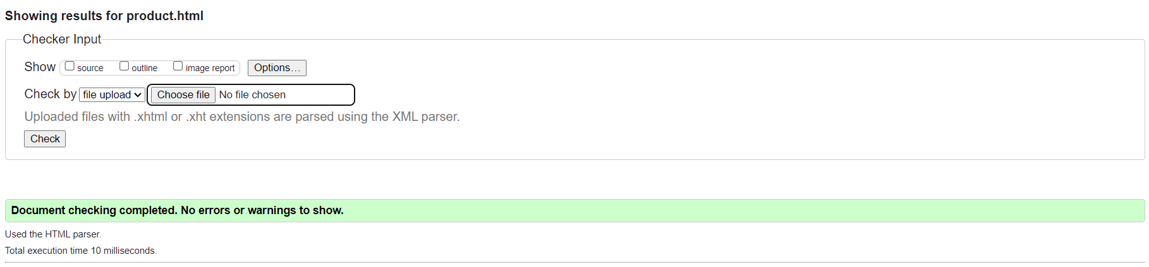

This is a HTML Validation for the product page of the website. As shown in the image above there are no errors showing for any of the code in the webpage has errors. This means that the website code will be fully functional and there is no broken code in the webpage meaning that the users won’t have any issues with elements in the webpage loading in. for the product page this is key since it has the main income for the company, and JavaScript is used for all the reviews in the product review section. If the HTML code has a single error, it would severely hamper user experience. It would limit a screen readers capability of reading the webpage therefore reducing the accessibility of the webpage because users with visual impairments rely on a screen reader as there way of accessing the content on the website, without it they would have no way of interacting with the website successfully and it would limit the amount of users accessing the webpage therefore costing Robot Juice money as well as the potential to be facing lawsuits from affected users. As well as this if the purchasing of goods doesn’t work correctly then the income that could have been generated from goods being brought is cancelled out causing a huge loss of income for Robot Juice.

**style.CSS CSS Validation**

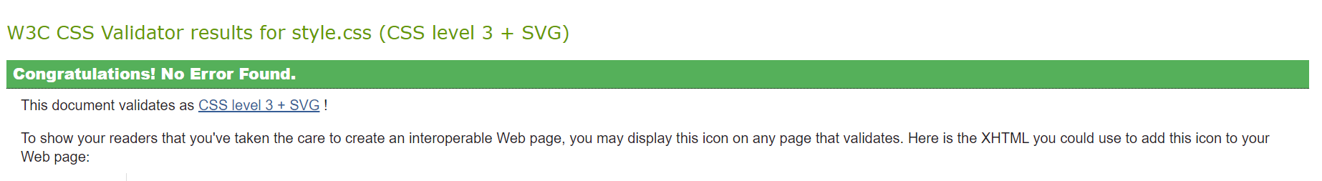

This is a CSS validation for the style.css stylesheet. This ensures that all the CSS styles in the document have no errors in the code. As seen above the code in style.css has no errors meaning that every style on the website fully functions and allows the website to work effectively. The style.css stylesheet oversees the styling of the website, such as colours font styles, font decoration and anything else that relates to the styling of the designs.

**grid.CSS CSS Validation**

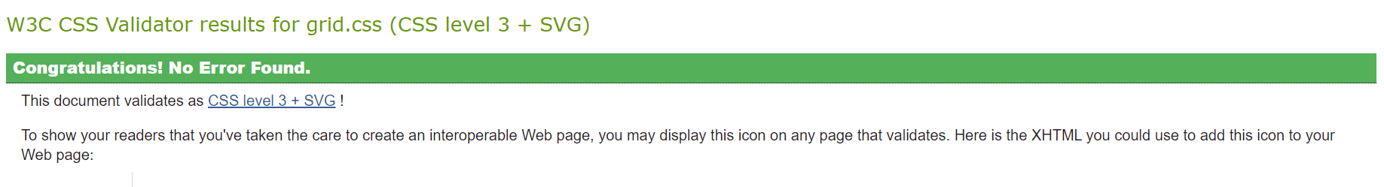

This is a CSS validation for the grid.css stylesheet. This ensures that all the CSS styles in the document have no errors in the code. The above image shows that the code has passed the validation and that all the elements on the website will stay where they are meant to be on the website. The grid.css stylesheet oversees the placements of the elements on the website. This ensures that the structure of the website works correctly, and that the website follows the specified structure for the website.

# References

References for Code fully referenced in the comments of the code itself.

References for Report

W3C, 2014. The W3C CSS Validation Service [Online] Available from: <https://teaching.computing.edgehill.ac.uk/validator/css/validator> [Accessed 11th December 2023]

NU, 2014. The NU HTML Checker [Online] Available from: <https://teaching.computing.edgehill.ac.uk/validator/html/> [Accessed 11th December 2023]

Qubika,2022. The best guide to validation testing [online] Available from: <https://qubika.com/blog/validation-testing/#:~:text=Validation%20testing%20typically%20occurs%20during,unit%20testing%2C%20and%20integration%20testing>. [Accessed 13th December 2023]

Chrome Web Store,2023. Arc Toolkit [Online Tool] Available from: <https://chromewebstore.google.com/detail/arc-toolkit/chdkkkccnlfncngelccgbgfmjebmkmce> [Accessed 18th December 2023]

W3,2023. Web Content Accessibility Guidelines (WCAG 2.1) [Online] Available from: <https://www.w3.org/TR/WCAG21/> [Accessed 15th December 2023]